Standard Operating Procedure for Cobalt(II) Chloride Hydrate

# Section 1 – Lab-Specific Information

**Building/Room(s) covered by this SOP: BAG 005, 023**

**Unit or department: Chemistry**

**Principal Investigator Name: Sarah Keller**

**Principal Investigator Signature/Date:** ** 28 February 2025**

**This SOP was created by (if not PI): Kent Wilson/Graduate Student/2-26-2025**

**Name/Title/Date/Signature**

# Section 2 – Hazards

* **Cobalt(II) Chloride Hydrate – CAS# 69098-14-2**; also known as Cobaltous chloride hydrate is a reddish violet powder frequently used to make jewelry, orthopedic and dental implants and dental prosthesis, paint/enamels/finishes, clothing fasteners, metal alloys and other products.
* Causes serious eye damage.
* Skin and respiratory sensitizer.
* Suspected of causing genetic defects (mutagen).
* May cause cancer by inhalation. Confirmed animal carcinogen. Classified by IARC as Group 2A: Probably Carcinogenic to Humans and by the NTP as Reasonably Anticipated to be a Human Carcinogen.
* Possible teratogen. May damage fertility or the unborn child.
* Irritating to the skin, eyes, mucous membranes and respiratory tract.
* Skin contact may cause inflammation and discoloration.
* May be absorbed through the skin. Contact will stain the skin purple

**The SDS for Cobalt(II) Chloride Hydrate is found here:** [**https://mychem.ehs.washington.edu/Chemical/ViewSDS/1681382**](https://mychem.ehs.washington.edu/Chemical/ViewSDS/1681382)

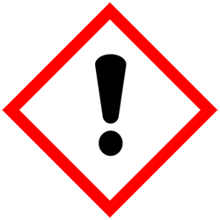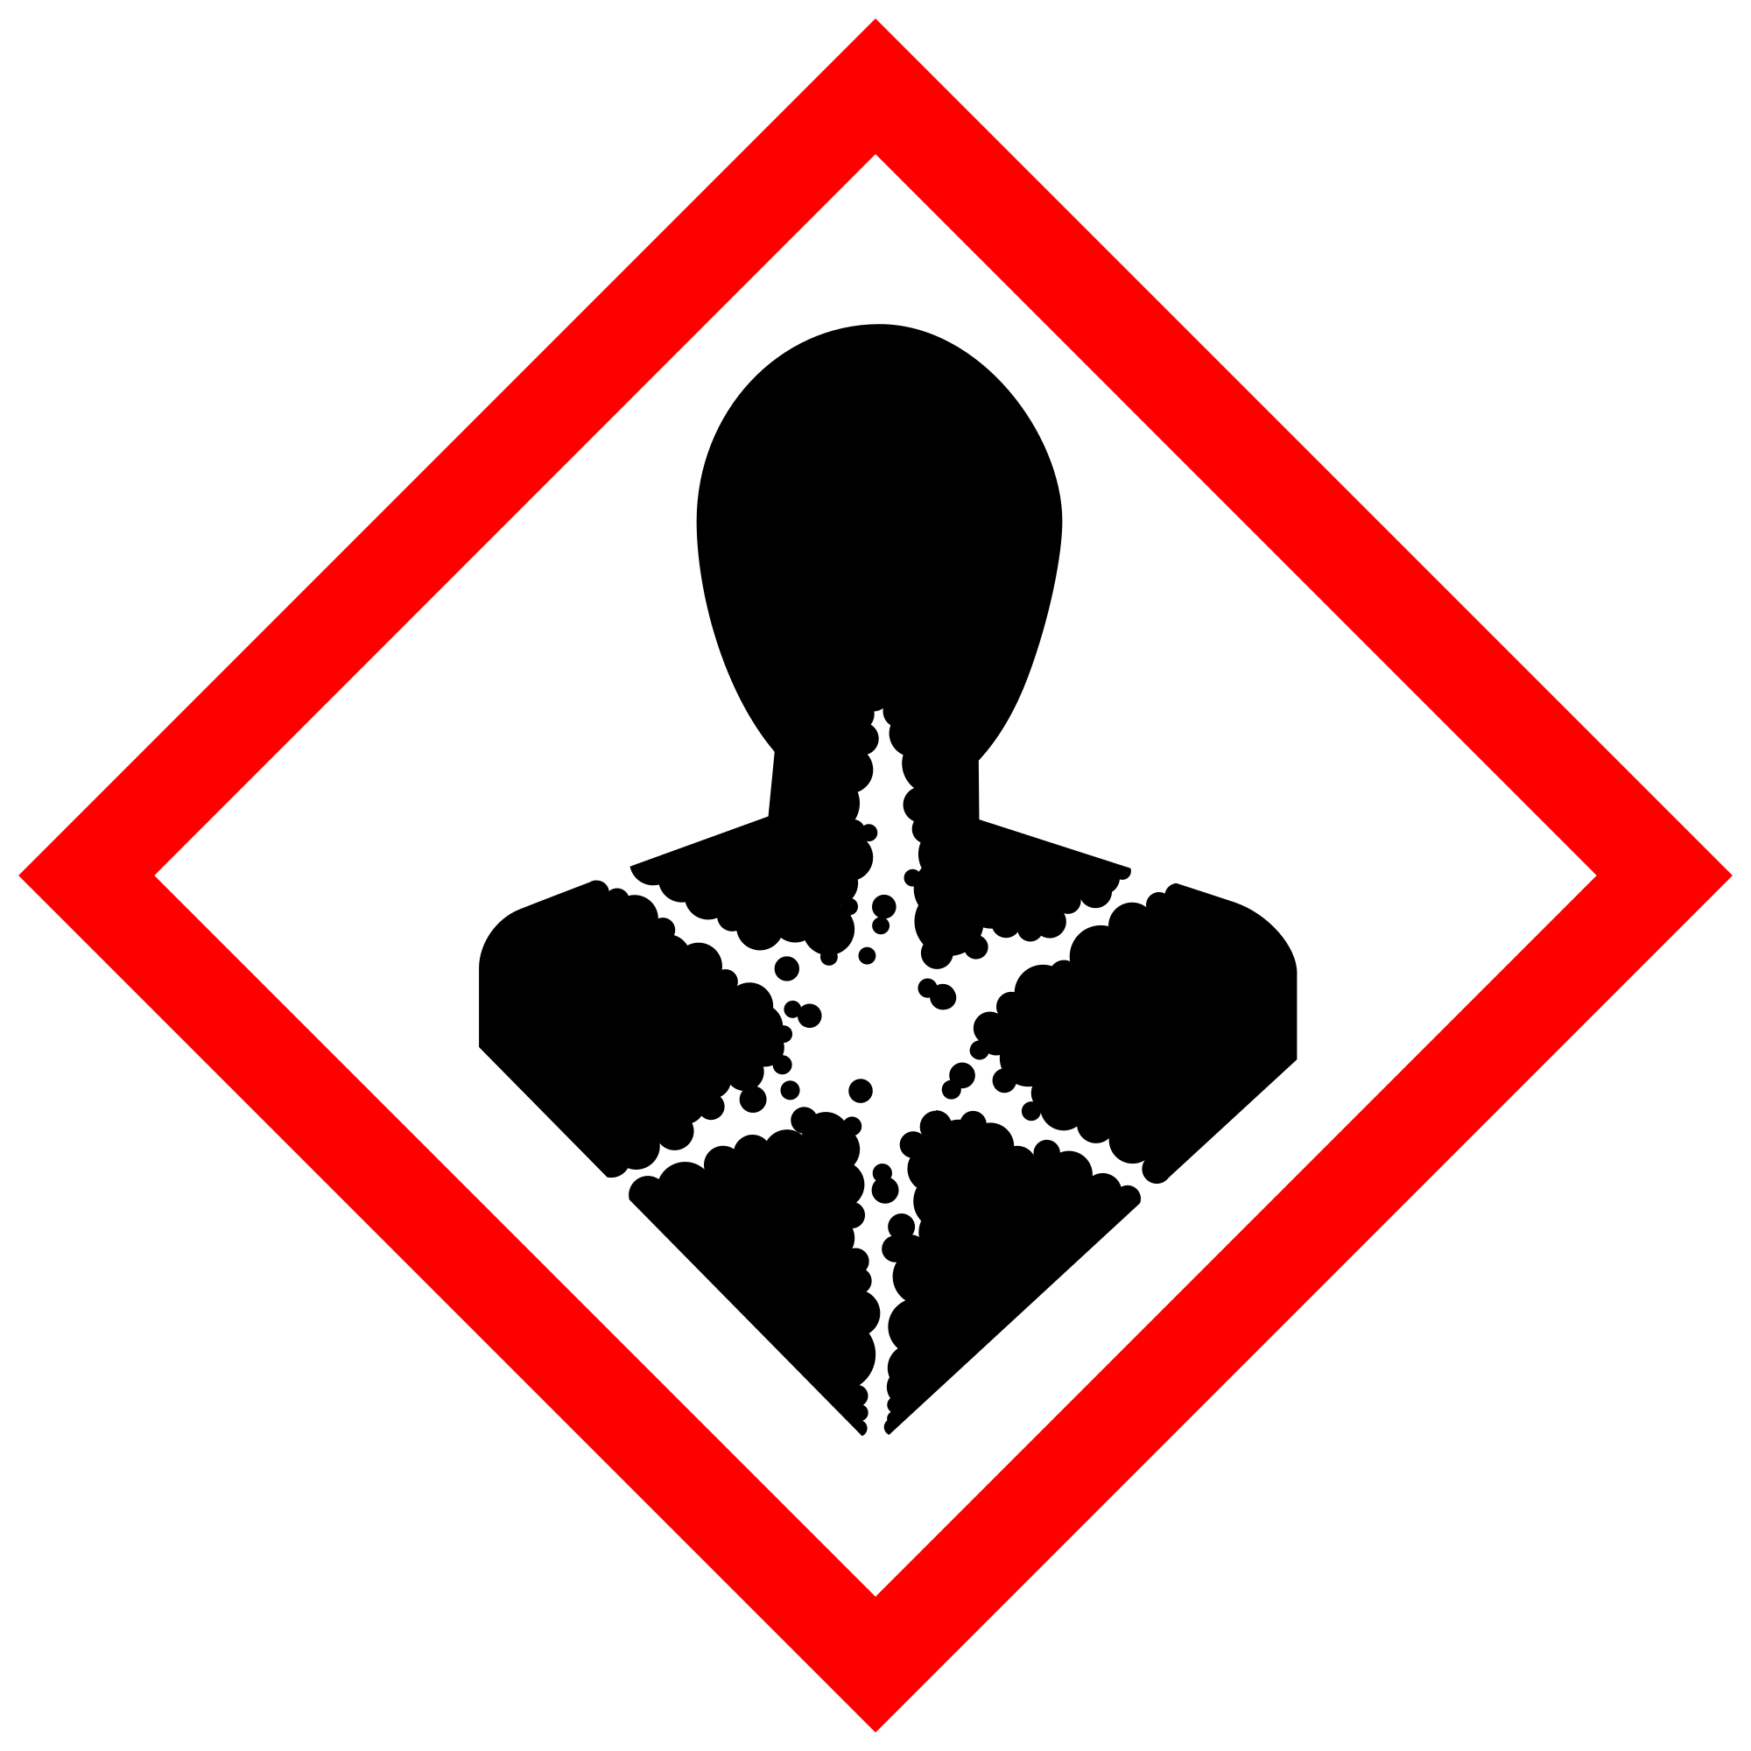 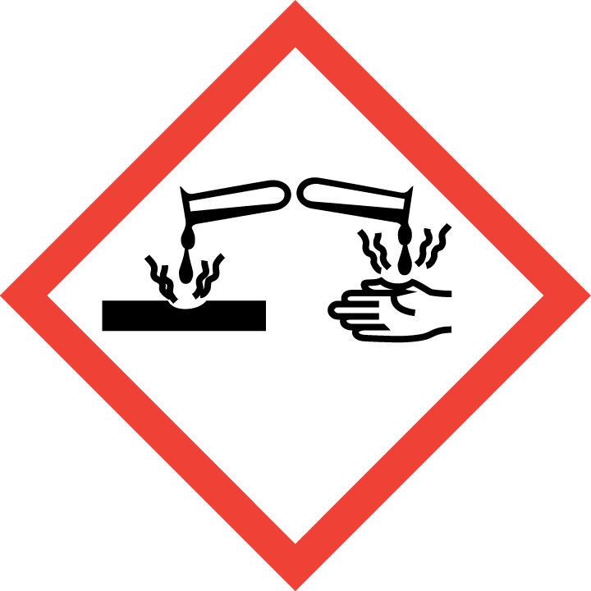 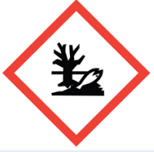

# Section 3 – Engineering Controls and Personal Protective Equipment (PPE)

## Engineering controls

A system of local and/or general exhaust is recommended to keep employee exposures as low as possible. Local exhaust ventilation is generally preferred because it can control the emissions of the contaminant at its source, preventing dispersion of it into the general work area. Any chemical fume hood used must be tested and passed by EH&S.

## Hygiene measures

Avoid contact with skin, eyes, and clothing. Wash hands after removing PPE, before breaks, and immediately after handling the chemical. If Imidazole come(s) into contact with any PPE, the PPE shall be immediately removed and discarded properly. Any potentially exposed body parts should be washed immediately.

## Skin and body protection

Chemically compatible laboratory coats that fully extend to the wrist must be worn and be appropriately sized for the individual and buttoned to their full length.  Lab coats available in the Chem Stockroom are the proper type. Personnel must also wear full-length pants, or equivalent, and close-toe shoes. The area of skin between the shoe and ankle must not be exposed.

## Hand protection

Hand protection is required for the activities described in this SOP.Double nitrile gloves are the standard practice for handling the solid powder. Nitrile gloves are available in the Chem Stockroom.Gloves must be inspected prior to use, including a check for pinholes.

Use proper glove removal technique (without touching glove’s outer surface) to avoid skin contact with this product. Dispose of contaminated gloves after use in accordance with applicable laws and good laboratory practices. Wash and dry hands immediately after glove removal.

## Eye protection

ANSI Z87.1-compliant eye protection is required for all work with Imidazole. Ordinary prescription glasses will NOT provide adequate protection unless they also meet the Z87.1 standard and have compliant side shields. Safety glasses are the minimum eye protection; goggles and face shields may also be used.

## Respiratory protection

Always work within a properly functioning certified laboratory chemical fume hood. Respiratory protection is not required for the activities described in this SOP.For conditions of use where exposure to the dust or mist is apparent, a half-face dust/mist respirator may be worn. For emergencies or instances where the exposure levels are not known, use a full-face positive-pressure, air-supplied respirator.

# Section 4 – Special handling and storage requirements

Store Cobalt(II) chloride hydrate containers upright in a designated, labeled area such as a chemical storage cabinet. Secondary containment such as a Nalgene/polypropylene tub is recommended. Cobalt(II) chloride hydrate solutions should always be stored below eye level. Storage area should be a secured, cool and well-ventilated area away from direct sunlight, heat, sparks, flame, or other sources of ignition.

Store Cobalt(II) chloride hydrate in a designated, labeled, secure storage area away from other types of chemicals. Avoid incompatible chemicals such as strong oxidizing agents and alkali metals (see below) If storage space is limited, use secondary containment such as a Nalgene/polypropylene tubs.

Store in tightly closed original container until ready for use. Immediately close all containers after use. Containers should be in good condition and compatible with material.

Transport Cobalt(II) chloride hydrate between locations in secondary containment, such as polyethylene or other non-reactive, non-breakable bottle carrier.

Purchase and store smallest quantities and lowest concentration needed for experimentation and what can be stored safely in the laboratory.

Do not use particularly hazardous substances such as Cobalt(II) chloride hydrate if less-hazardous alternatives are possible.

Do not dispense Cobalt(II) chloride hydrate directly onto a laboratory balance in the general lab space. Use an enclosed balance or secondary enclosure within the fume hood if possible. Alternatively, transfer the material into a sealable, pre-tared container inside the fume hood, then take the sealed container to the balance. Adjust the amount of material inside the container until the desired mass is reached. Make all adjustments inside the fume hood.

Containers of this material may be hazardous when empty since they retain product residues (dust, solids); observe all warnings and precautions listed for the product.

Users of chemicals are required to follow [labeling requirements](https://www.ehs.washington.edu/chemical/chemical-container-labels) when transferring chemicals to secondary containers and when labeling containers with chemical waste, UW-synthesized chemicals, [peroxide-forming chemicals](https://www.ehs.washington.edu/resource/ehs-guidelines-peroxide-forming-chemicals-168), and [Chemicals of Interest](https://www.cisa.gov/appendix-chemicals-interest). Requirements for labeling containers and templates for creating labels are available on the [EH&S website](http://www.ehs.washington.edu/chemical/chemical-container-labels).

Check [Section 2 of the Lab Safety Manual](https://www.ehs.washington.edu/resource/laboratory-safety-manual-510) and the [Chemical Compatibility Chart](https://www.ehs.washington.edu/system/files/resources/Incompatible_Chemicals_Focus_Sheet.pdf) on the EH&S website for incompatible chemical groups.

Check [Section 2 of the Lab Safety Manual](https://www.ehs.washington.edu/resource/laboratory-safety-manual-510) for information on chemical transport practices.

# Section 5 – Spill and accident procedures

Chemical spills must be cleaned up as soon as possible by personnel wearing proper PPE. All other persons should leave the area.

Do not attempt to clean up any spill if you are not comfortable doing so or if you feel unsure of your ability to complete the task safely. In this situation, evacuate the area and call 9-1-1 on campus phone for help. If the spill is out of control, call 9-1-1. If a person is injured, exposed or suspected of being exposed, call 9-1-1 and follow the EXPOSURE PROCEDURES (below).

Spill area must be cleaned up in the following manner:

• Notify all lab personnel of spills (with the details of the spill and actions being taken) and regulate access, as necessary, to the area.

• Spill volumes less than approximately 25ml/25g can be cleaned by lab personnel as follows:

• If a small amount of Cobalt(II) chloride hydrate is spilled (it can be cleaned up in 10 minutes) and you have been appropriately trained to clean it up, you may do so.

• For spill volumes greater than approximately 25ml/25g, contact the PI for assistance. If the PI is unavailable, contact EH&S.

• Personnel cleaning the spill shall, at minimum, wear the same PPE required for the handling and use of cobalt(II) chloride hydrate .

• In the event of skin contact, immediately remove contaminated clothing and wash affected areas with soap and copious amounts of water.

• In case of contact with eyes, immediately flush eyes with copious amounts of water for at least 15 minutes and subsequently obtain medical attention.

• If inhalation produces excessive health symptoms, immediately relocate to fresh air and subsequently obtain medical attention.

• In the event of ingestion, obtain immediate medical attention. Do not induce vomiting unless directed to do so by medical personnel.

• Report all spills, regardless of size, to laboratory PI,

Spill cleanup materials must be disposed of by double bagging them in plastic bags labeled with the contents. Submit a request for EH&S to pick up the materials.

 For questions on spill cleanup, contact EH&S spill consultants at 206‐543‐0467 during normal business hours (Monday-Friday, 8 a.m. to 5 p.m.).

Any spill, exposure or near miss incident requires the involved person or supervisor to complete and submit the [Online Accident Reporting System (OARS)](https://www.ehs.washington.edu/workplace/accident-and-injury-reporting) form on the EH&S website within 24 hours ([certain types of incidents](https://ehs.washington.edu/workplace/accident-and-injury-reporting) require immediate notification) at oars.ehs.washington.edu.

**Exposures:** If a person is injured, exposed, or suspected of being exposed to cobalt(II) chloride hydrate , follow procedures listed here:

**Perform first aid immediately.**

* **Inhalation exposure**: Move out of contaminated area; get medical help.
* **Sharps injury** (needle stick or subcutaneous exposure): Scrub exposed area thoroughly for 15 minutes using warm water and sudsing soap.
* **Skin exposure:** Use the nearest safety shower for 15 minutes; stay under the shower and remove clothing; use a clean lab coat or spare clothing for cover‐up.
* **Eye exposure:** Use the eye wash for 15 minutes while holding eyelids open.

**Get Help.**

* **Call** 9-1-1 or go to nearest Emergency Department (ED); provide details of exposure:
  + - Agent
    - Dose
    - Route of exposure
    - Time since exposure
* **Bring** **the SDS and this SOP** to the Emergency Department
* **Notify your supervisor** as soon as possible for assistance
* **Secure the area** before leaving; lock doors and indicate spill if needed

**Report the incident to Environmental Health & Safety**.

* **Notify** **EH&S immediately** after providing first aid and/or getting help.
  + During business hours (M‐F/8‐5), call 206‐543‐7262.
  + Outside of business hours, call 206‐685‐UWPD (8973) to be routed to EH&S Staff On Call.
* Any spill, exposure or near miss incident requires the involved person or supervisor to complete and submit the [UW Online Accident Reporting System](https://oars.ehs.washington.edu/) (OARS) form on the EH&S website within 24 hours (certain [types of incidents require immediate notification](https://www.ehs.washington.edu/workplace/incident-reporting)).

# Section 6 – Waste accumulation and disposal procedures

**Waste Cobalt(II) chloride hydrate** in its pure form and solutions greater than or equal to 10% must be managed as hazardous waste. It should be collected in a separate container for collection by EH&S.

Refer to the SDS and [UW Laboratory Safety Manual](https://www.ehs.washington.edu/resource/laboratory-safety-manual-510), Section 3 for guidance on waste handling, labeling, accumulation, storage and pickup.

Per [UW Administrative Policy Statement 11.2](https://www.washington.edu/admin/rules/policies/APS/11.02.html), the University of Washington Environmental Health & Safety Department has full responsibility for collection of hazardous waste for the University, all its campuses, and off-site locations; **University laboratories cannot contract with an outside vendor to collect hazardous waste.**

**Be aware that many laboratory accidents happen from inadvertent disposal of** [**incompatible wastes**](https://www.ehs.washington.edu/system/files/resources/Incompatible_Chemicals_Focus_Sheet.pdf) **into the same waste container.** Therefore, identify different waste streams as appropriate.

**Accumulate waste at the point of generation** in a sturdy jar with a securely-closable/screw‐top lid. Spill cleanup materials must be disposed of by double bagging them in plastic bags labeled with the contents.

Email [labcheck@uw.edu](mailto:labcheck@uw.edu) with questions.

Manage chemical and hazardous chemical waste separately from other waste streams such as biohazardous waste. Never autoclave chemical waste because it can produce hazardous chemical vapors, aerosols, and explosive reactions.

In certain cases, chemical waste can be treated and disposed of into the sanitary sewer or exchanged with other University units. [Chemical treatment and recycling](https://www.ehs.washington.edu/chemical/chemical-treatment-and-recycling) and [chemical exchange](https://www.ehs.washington.edu/chemical/chemical-exchange) options and are available on the EH&S website.

**All chemical waste containers must be labeled** with a [UW Hazardous Waste Label](https://www.ehs.washington.edu/chemical/hazardous-chemical-waste-disposal). Refer to [How to Label Chemical Waste Containers](https://www.ehs.washington.edu/system/files/resources/how-to-label-chemical-waste-containers.pdf).

To request a collection of chemical waste, submit a form on the [Chemical Waste Disposal](https://www.ehs.washington.edu/chemical/hazardous-chemical-waste-disposal) webpage on the EH&S website or directly in [MyChem](https://www.ehs.washington.edu/chemical/mychem) inventory. Contact EH&S at 206.616.5835 or [chmwaste@uw.edu](mailto:chmwaste@uw.edu) with questions.

Work area decontamination procedures as described in the section on spills should be followed, using PPE described above.

Visit the [Hazardous Material Disposal and Recycling](https://www.ehs.washington.edu/popular-services/hazardous-material-disposal-and-recycling) webpage on the EH&S website for information on disposing, recycling and surplusing materials.

# Section 7 – Protocol

Protocols for handling cobalt(II) chloride hydrate in the Keller Lab are the same as outlined in Sections 3 and 4 above.

Refer to Section 2 of the [UW Laboratory Safety Manual](https://www.ehs.washington.edu/resource/laboratory-safety-manual-510) on the EH&S website for additional guidance on chemical management and preparation for use for [particularly hazardous substances](https://www.ehs.washington.edu/resource/particularly-hazardous-substances-655) (PHSs).

**NOTE:** Any deviation from this SOP requires approval from Principal Investigator.

# Section 8 – Special Precautions for animal use (Not applicable)

This section is not applicable (“N/A”) because our lab does not use animals

[**PARTICULARLY HAZARDOUS SUBSTANCE**](https://www.ehs.washington.edu/resource/particularly-hazardous-substances-655) **INVOLVED?**

**☒YES: Sections #9 to #11 are Mandatory.**

**☐NO: Sections #9 to #11 are Optional.**

# Section 9 – Approvals required

All staff working with cobalt(II) chloride hydrate must be trained on this SOP prior to starting work. They must also review the cobalt(II) chloride hydrate SDS, which is available through the Keller Laboratory website and EH&S.

**Section 10 – Decontamination**

• If the eyes or body of any person may have been exposed, a safety shower/eye wash must be available for immediate use. Personnel who are working with cobalt(II) chloride hydrate must be aware of location of nearest Safety Shower/Eye Wash and verify that a current certification of performance tag is present.

• Personnel shall rinse exposed areas of skin and/or eyes with copious amounts of water for at least 15 minutes.

• All equipment, materials and work surfaces that have/ potentially have become contaminated shall be cleaned in accordance with those identified for small spill in Section 5.

# Section 11 – Designated area

Always work in a properly functioning, certified laboratory chemical fume hood.

# Section 12 – Documentation relevant to ALL Particularly Hazardous Substances

* Lab members are expected to review the laboratory’s inventory of chemicals to identify any “Particularly Hazardous” substances. The inventory appears in MyChem with the letters “P” or “B” in the column labeled “Reg”.
* Before working with any of the “Particularly Hazardous” substances, lab members must review the laboratory’s SOP for that substance to learn how to protect themselves from the hazards and how to enact emergency procedures.
* Ready access to SOPs and to a Safety Data Sheets for all Particularly Hazardous materials used in the Keller Lab are available through the Keller Lab website.
* If any lab member determines that the SOP should be revised or if the substance is being used in a way that is not covered in the SOP, the lab member should bring it to the attention of the PI and propose changes to this SOP.
* Lab members must attest (in a separate document that applies to all Particularly Hazardous substances) that they will adhere to the policies in this SOP.